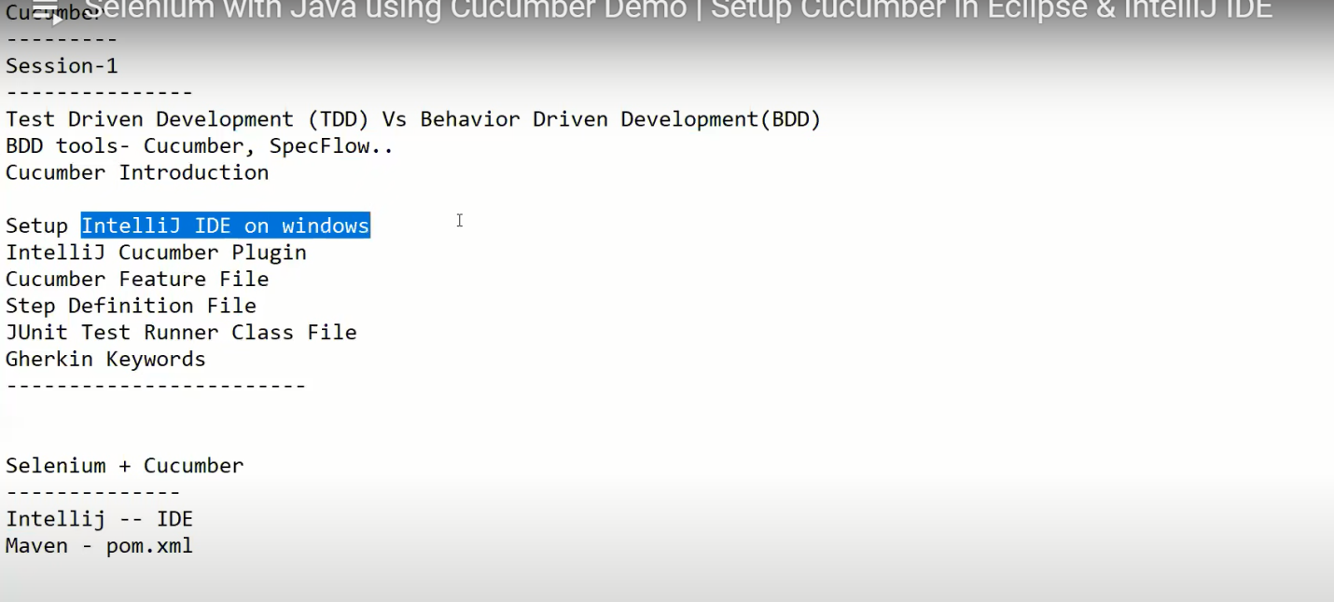

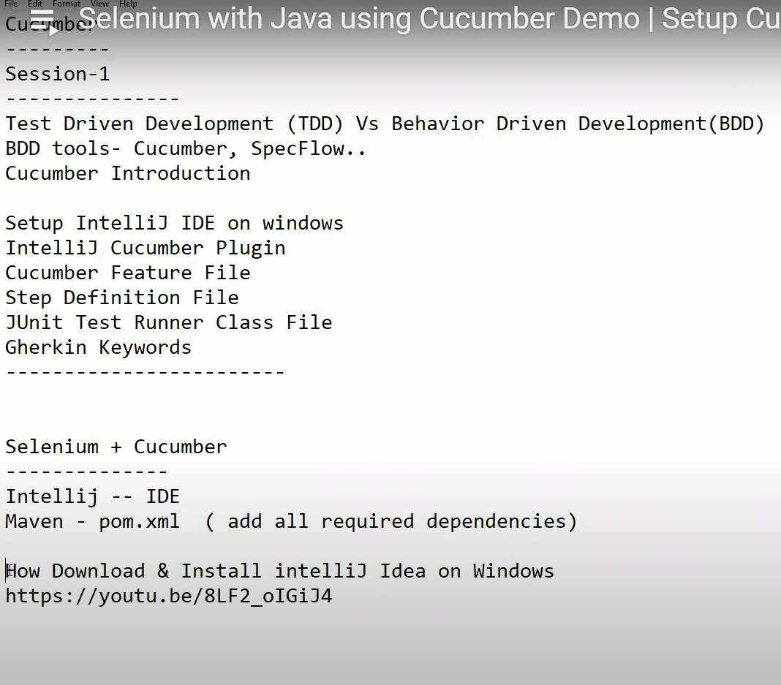

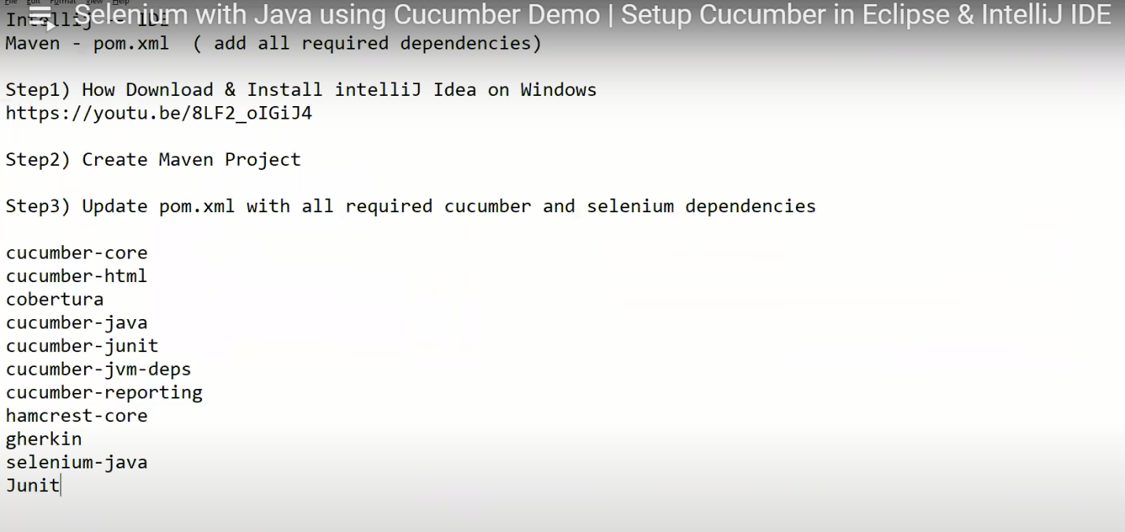

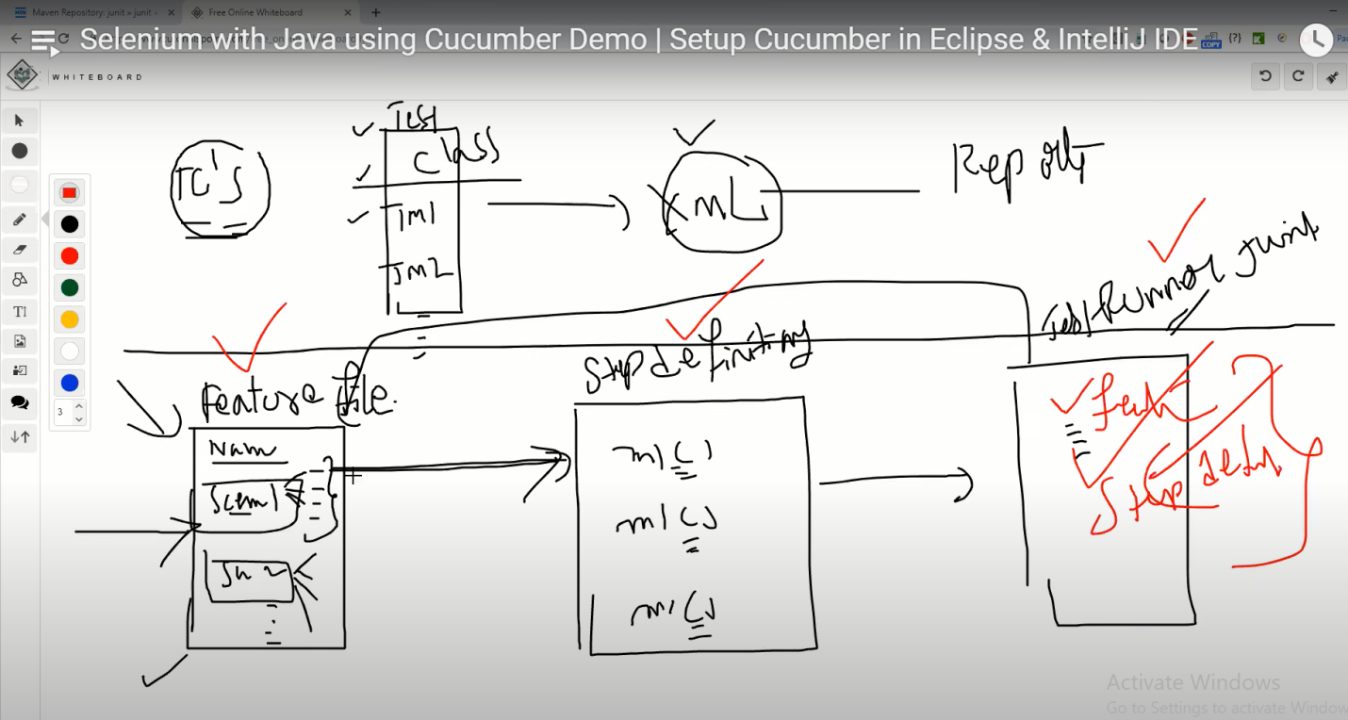

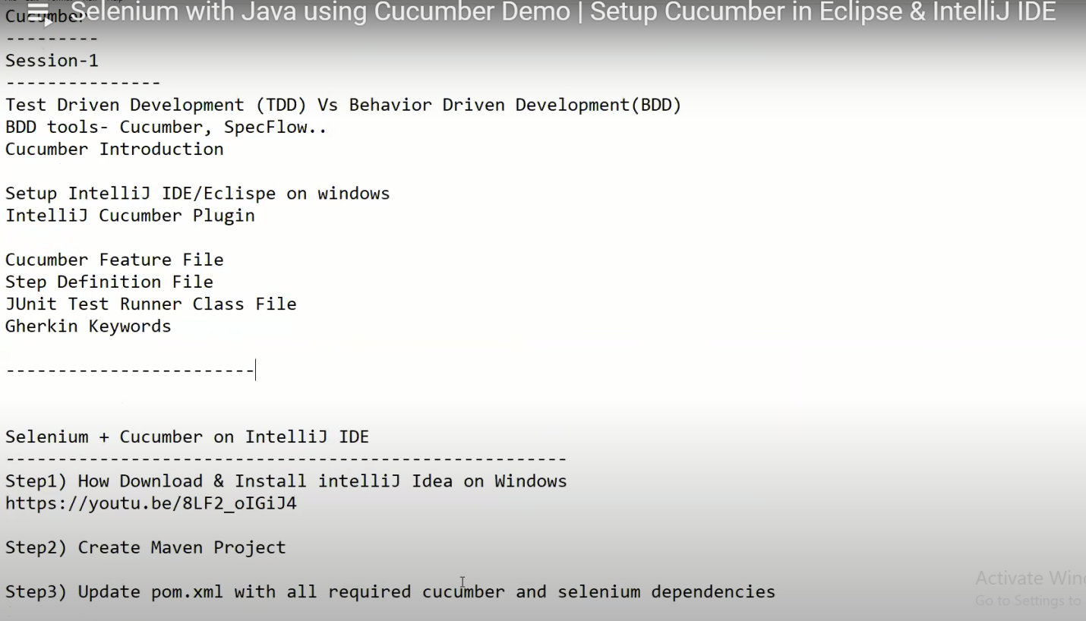

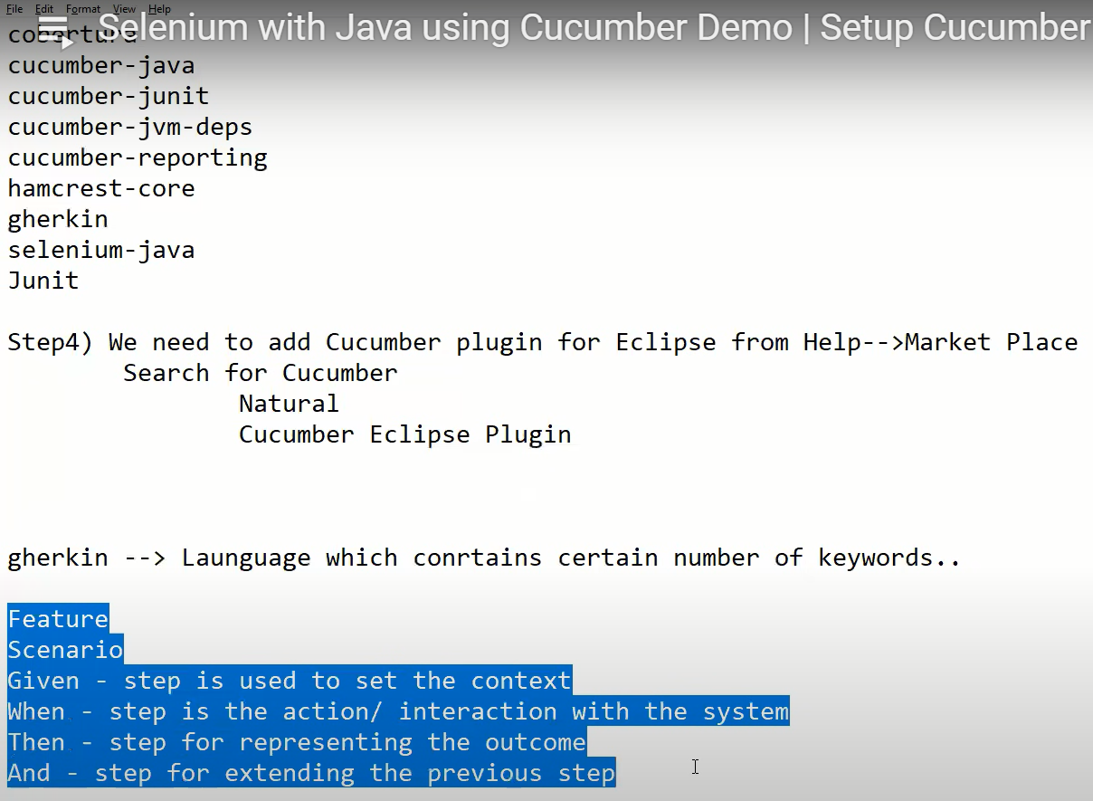

Topics Covered: ---------- Test Driven Development (TDD) Vs Behavior Driven Development(BDD)

BDD tools- Cucumber, SpecFlow..

Cucumber Introduction

Setup IntelliJ IDE/Eclipse on windows

Cucumber Feature File

Step Definition File

JUnit Test Runner Class File

Gherkin Keywords Notes: -------------- Selenium + Cucumber setup on IntelliJ IDE -----------------------------------------

Step1) How Download & Install intelliJ Idea on Windows [https://youtu.be/8LF2_oIGiJ4](https://www.youtube.com/watch?v=8LF2_oIGiJ4&t=0s)

Step2) Create Maven Project

Step3) Update pom.xml with all required cucumber and selenium dependencies

Cucumber-java

Cucumber-junit

Cucumber-reporting

selenium-java

webdrivermanager

poi poi-ooxml

log4j-core

log4j-api

extentreports

commons-io

commons-lang3

commons-email

Step4)Add IntelliJ Cucumber for Java Plugin Select project--File--Setings--Plugins--Search for "Cucumber for Java"

Step5) We need to add JUnit & Hamcrest libraries to your project from IntelliJ installation location(lib folder)

Selenium + Cucumber setup on Eclipse IDE ----------------------------------------- Step 1) Install Java & Eclipse

Step2) Create Maven Project

Step3) Update pom.xml with all required cucumber and selenium dependencies ** Same dependencies mensioned above

Step4) We need to add Cucumber plugin for Eclipse from Help--Market Place Search for Cucumber Natural Cucumber Eclipse Plugin

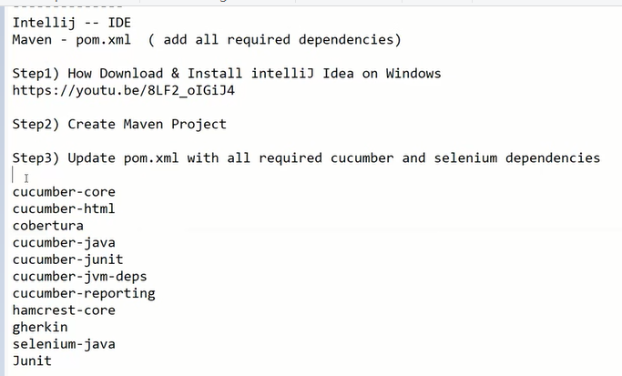

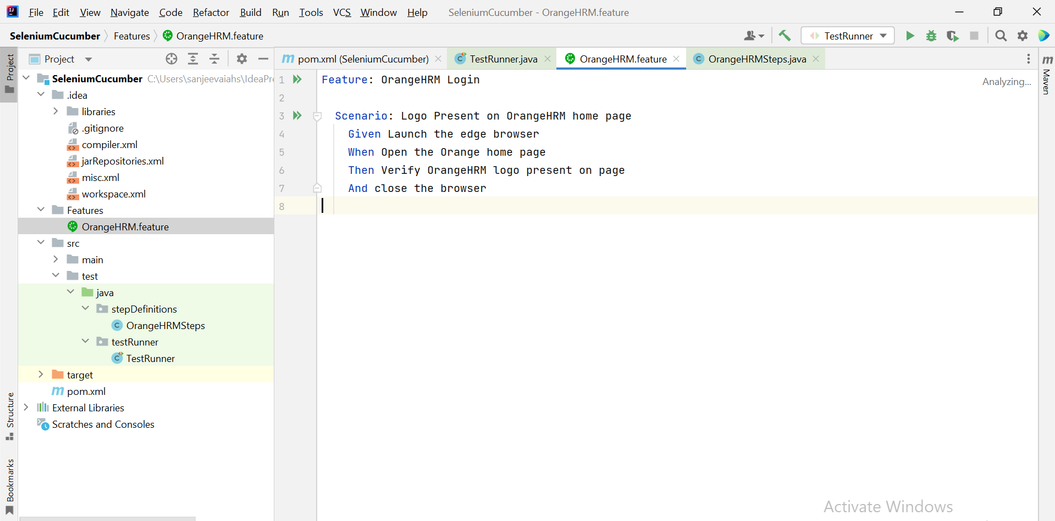

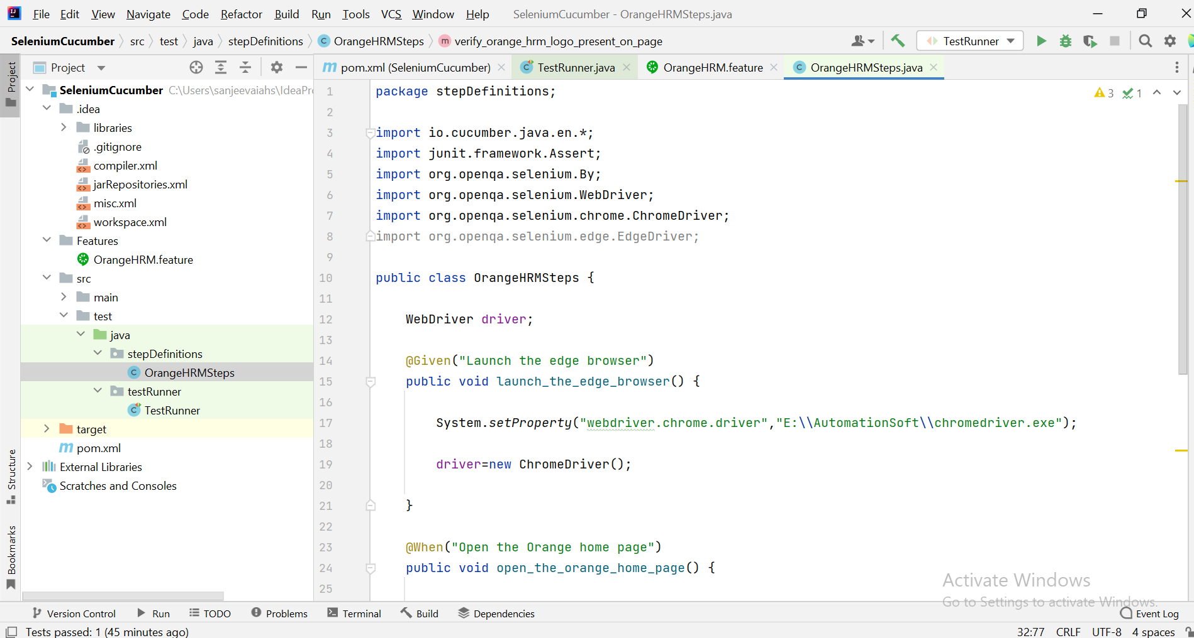

package stepDefinitions;  
  
import io.cucumber.java.en.*;  
import junit.framework.Assert;  
import org.openqa.selenium.By;  
import org.openqa.selenium.WebDriver;  
import org.openqa.selenium.chrome.ChromeDriver;  
import org.openqa.selenium.edge.EdgeDriver;  
  
public class OrangeHRMSteps {  
  
 WebDriver driver;  
  
 @Given("Launch the edge browser")  
 public void launch_the_edge_browser() {  
  
 System.*setProperty*("webdriver.chrome.driver","E:\\AutomationSoft\\chromedriver.exe");  
  
 driver=new ChromeDriver();  
  
 }  
  
 @When("Open the Orange home page")  
 public void open_the_orange_home_page() {  
  
 driver.get("https://opensource-demo.orangehrmlive.com/");  
 }  
  
 @Then("Verify OrangeHRM logo present on page")  
 public void verify_orange_hrm_logo_present_on_page() {  
  
 boolean status=driver.findElement(By.*xpath*("//*[@id=\"divLogo\"]/img")).isDisplayed();  
 Assert.*assertEquals*(true,status);  
 }  
  
 @And("close the browser")  
 public void close_the_browser() {  
 driver.close();  
 }  
  
  
}

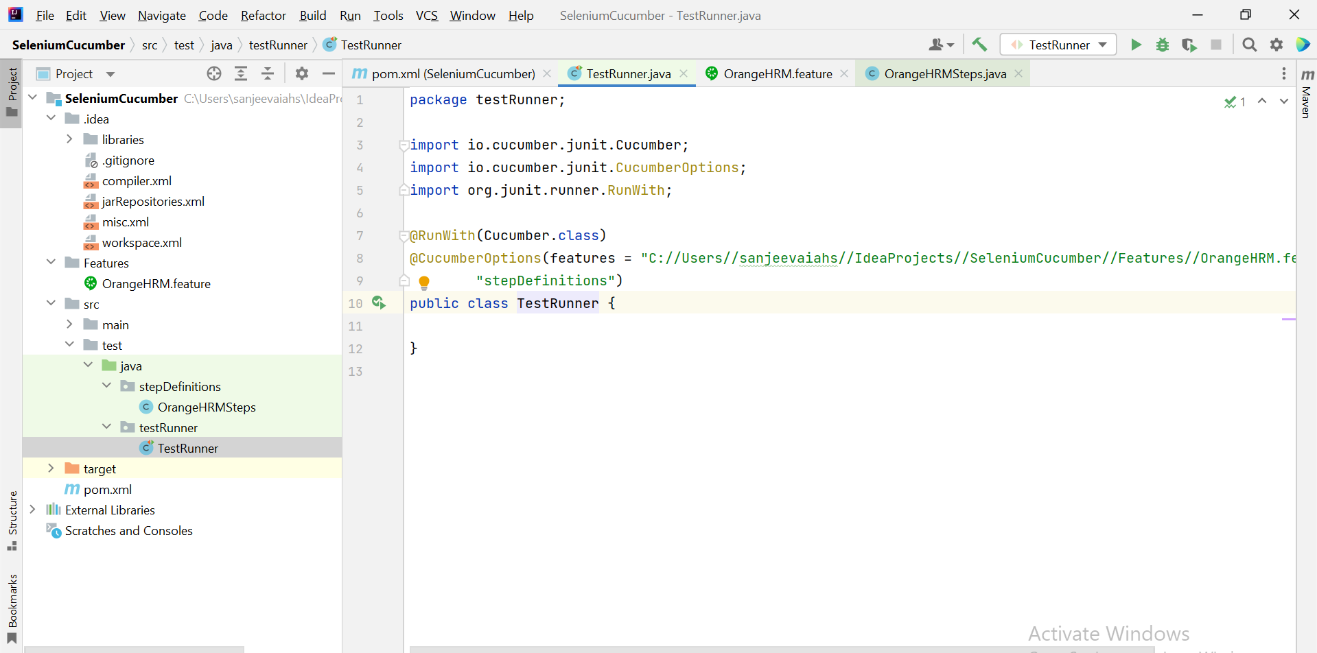

package testRunner;  
  
import io.cucumber.junit.Cucumber;  
import io.cucumber.junit.CucumberOptions;  
import org.junit.runner.RunWith;  
  
@RunWith(Cucumber.class)  
@CucumberOptions(features = "C://Users//sanjeevaiahs//IdeaProjects//SeleniumCucumber//Features//OrangeHRM.feature",glue=  
 "stepDefinitions")  
public class TestRunner {  
  
}

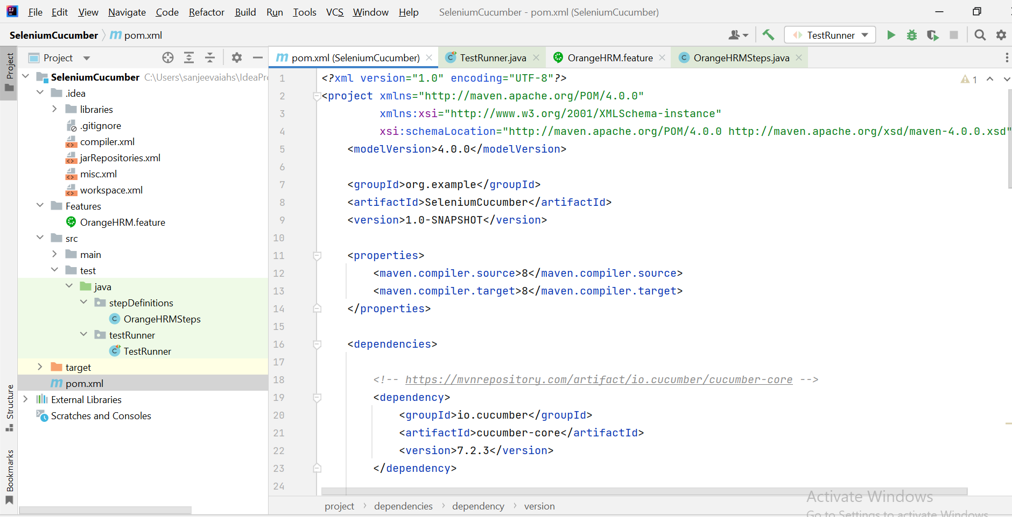

*<?*xml version="1.0" encoding="UTF-8"*?>*<project xmlns="http://maven.apache.org/POM/4.0.0"  
 xmlns:xsi="http://www.w3.org/2001/XMLSchema-instance"  
 xsi:schemaLocation="http://maven.apache.org/POM/4.0.0 http://maven.apache.org/xsd/maven-4.0.0.xsd">  
 <modelVersion>4.0.0</modelVersion>  
  
 <groupId>org.example</groupId>  
 <artifactId>SeleniumCucumber</artifactId>  
 <version>1.0-SNAPSHOT</version>  
  
 <properties>  
 <maven.compiler.source>8</maven.compiler.source>  
 <maven.compiler.target>8</maven.compiler.target>  
 </properties>  
  
 <dependencies>  
  
 *<!-- https://mvnrepository.com/artifact/io.cucumber/cucumber-core -->* <dependency>  
 <groupId>io.cucumber</groupId>  
 <artifactId>cucumber-core</artifactId>  
 <version>7.2.3</version>  
 </dependency>  
  
 *<!-- https://mvnrepository.com/artifact/io.cucumber/cucumber-html -->* <dependency>  
 <groupId>io.cucumber</groupId>  
 <artifactId>cucumber-html</artifactId>  
 <version>0.2.7</version>  
 </dependency>  
  
 *<!-- https://mvnrepository.com/artifact/net.sourceforge.cobertura/cobertura -->* <dependency>  
 <groupId>net.sourceforge.cobertura</groupId>  
 <artifactId>cobertura</artifactId>  
 <version>2.1.1</version>  
 <scope>test</scope>  
 </dependency>  
 *<!-- https://mvnrepository.com/artifact/io.cucumber/cucumber-java -->* <dependency>  
 <groupId>io.cucumber</groupId>  
 <artifactId>cucumber-java</artifactId>  
 <version>7.2.3</version>  
 </dependency>  
 *<!-- https://mvnrepository.com/artifact/io.cucumber/cucumber-junit -->* <dependency>  
 <groupId>io.cucumber</groupId>  
 <artifactId>cucumber-junit</artifactId>  
 <version>7.2.3</version>  
 <scope>test</scope>  
 </dependency>  
 *<!-- https://mvnrepository.com/artifact/io.cucumber/cucumber-jvm-deps -->* <dependency>  
 <groupId>io.cucumber</groupId>  
 <artifactId>cucumber-jvm-deps</artifactId>  
 <version>1.0.6</version>  
 <scope>provided</scope>  
 </dependency>  
 *<!-- https://mvnrepository.com/artifact/net.masterthought/cucumber-reporting -->* <dependency>  
 <groupId>net.masterthought</groupId>  
 <artifactId>cucumber-reporting</artifactId>  
 <version>5.7.0</version>  
 </dependency>  
 *<!-- https://mvnrepository.com/artifact/org.hamcrest/hamcrest-core -->* <dependency>  
 <groupId>org.hamcrest</groupId>  
 <artifactId>hamcrest-core</artifactId>  
 <version>2.2</version>  
 <scope>test</scope>  
 </dependency>  
 *<!-- https://mvnrepository.com/artifact/io.cucumber/gherkin -->* <dependency>  
 <groupId>io.cucumber</groupId>  
 <artifactId>gherkin</artifactId>  
 <version>22.0.0</version>  
 </dependency>  
 *<!-- https://mvnrepository.com/artifact/org.seleniumhq.selenium/selenium-java -->* <dependency>  
 <groupId>org.seleniumhq.selenium</groupId>  
 <artifactId>selenium-java</artifactId>  
 <version>4.1.1</version>  
 </dependency>  
 *<!-- https://mvnrepository.com/artifact/junit/junit -->* <dependency>  
 <groupId>junit</groupId>  
 <artifactId>junit</artifactId>  
 <version>4.13.2</version>  
 <scope>test</scope>  
 </dependency>  
  
 </dependencies>  
</project>

